**Time Series Analysis & Forecasting of PM2.5 in Delhi**

By

Rahul Rajesh Singh

A Research Project submitted in partial fulfillment

of the requirements for the degree of

Masters of Science in Statistics

Specialization in Data Science

At

Rutgers, The State University of New Jersey

December 2023

**Abstract**

Delhi, the capital city of India, ranks 4th on the list of the World’s Most Polluted Cities, and has been consistent with it for the past few years. Considering the adverse health effects these pollutants have on the residents, there is a pressing need to understand their patterns in order to forecast the upcoming levels and come up with remedial measures to mitigate their effects.

With this in mind, the objective of the project was to conduct time series analysis of a major (as described later) pollutant, PM2.5, to identify its pattern and trend. This analysis majorly focused on observing the pattern, and drawing insights which can later be used to control the relevant factors. Proceeding with these insights, the objective was expanded to that of a Univariate Time Series Forecasting. This was initially implemented using Statistical Methods like Seasonal Trend Decomposition, SARIMA and later using more sophisticated methods like TBATS, DHR. Later, some Machine Learning techniques were used like Random Forests, XGBoost and Neural Networks.

**Acknowledgement**

This Poster Presentation was made possible under the valuable guidance of Prof. Yaqing Chen who provided immense support through the project. A huge thanks to Rahul Singh, an indispensable member of the group, who was not only punctual with the meetings but also the deliverables; you have our deepest gratitude.

**Table of Content**

1. Introduction 1
2. Data Preparation 3
   1. Log Transform 3
   2. Outlier Treatment 4
   3. Data Imputation 4
3. Modeling Methodology 5
   1. Seasonal Decomposition 5
   2. Auto SARIMA 6
   3. DHR 7
   4. TBATS 8
   5. Random Forest 10
   6. XGBoost 11
   7. General Additive Model 11
   8. Long Short-Term Memory Cell 12
4. Observations 14
5. Conclusion & Future Scope 17
6. References 18
   1. Appendix 18
   2. Citations 18
   3. Bibliography 18

**List of Tables**

1. Train and Test RMSE for all the forecasts 14
2. Ljung Box and ARCH Test for DHR and TBATS 15
3. Ljung Box and ARCH Test for DHR and TBATS fitted with ARCH (1) 15

**List of Figures**

1. Distribution of Pollutants impacting AQI 2
2. Daily PM2.5 Series of Delhi 3
3. Daily Log PM2.5 Series of Delhi 3
4. Outliers Detected with their Replacements 4
5. Seasonal Decomposition of Log Series with Period 365 5
6. ACF and PACF of Residuals from Seasonal Decomposition 5
7. Residual analysis of SARIMA Model 6
8. Forecast for DHR Models with various values of K 7
9. Residual Plot with its ACF and PACF Plot for DHR 8
10. Forecast with the TBATS Model 9
11. Residuals of TBATS Model with their ACF and PACF Plots 9
12. Residuals of Random Forest Model with their ACF and PACF Plots 10
13. Residuals of XGBoost Model with their ACF and PACF Plots 11
14. Residuals of GAM Model with their ACF and PACF Plots 12
15. Residuals of LSTM Model with their ACF and PACF Plots 13
16. Trend and Seasonal Pattern of TBATS Model 14
17. Observed values and forecasts of all the models 14
18. Tableau Dashboard displaying the forecasts 16

**1. Introduction**

Delhi, the capital city of India, ranks 4th on the list of the World’s Most Polluted Cities, and has been consistent with it for the past few years. Considering the adverse health effects these pollutants have on the residents, there is a pressing need to understand their patterns in order to forecast the upcoming levels and come up with remedial measures to mitigate their effects.

With this in mind, the objective of the project was to conduct time series analysis of a major (as described later) pollutant, PM2.5, to identify its pattern and trend. This analysis majorly focuses on observing the pattern, and drawing insights which can later be used to control the relevant factors.   
Fortunately, a suitable dataset for this topic was available on Kaggle. The said dataset had Hourly Measurements of Concentration (in varying units) of Air Pollutants across various cities, for the period of January1, 2015 to June 16, 2020. Originally, these observations were taken across multiple stations in every city, but their values were later averaged per city, leading to a single record per city. The pollutants in the dataset were: PM2.5, PM10, NO, NO2, NOx, NH3, CO, SO2, O3, Benzene, Toluene, and Xylene. Along with these pollutants, there were two additional columns for AQI and AQI Bucket. The AQI or Air Quality Index is a metric devised to quantify the Air Pollution of a certain place at that specific time, based on the threshold concentrations of various pollutants. The following is a formula for Subindex of each pollutant:

Ip = ((IHi −ILo) * (Cp −BPLo ) / BPHi−BPLo) + ILo.  *Formula 1*

Where Ip = the index for pollutant p  
Cp = the truncated concentration of pollutant p  
BPHi = the concentration breakpoint that is greater than or equal to Cp BPLo = the concentration breakpoint that is less than or equal to Cp  
IHi = the AQI value corresponding to BPHi  
ILo = the AQI value corresponding to BPLo

Based on the above formula, subindices were calculated per pollutant for each available time frame, and the maximum of these subindices was selected as the AQI for the area. To identify the most significant pollutant, the highest subindex per time frame along with its corresponding pollutant must be noted. This information can be used to determine the most detrimental pollutant overall by aggregating the data. The pollutants with the maximum index for each time frame in Delhi are presented below, indicating the primary cause of pollution.



*Figure 1. Distribution of Pollutants Impacting the AQI*

As seen in Figure 1, PM2.5 was responsible for more than half of the instances of AQI and is thus considered the focus of this project. Going forward, it is assumed that the data consists of PM2.5 for Delhi alone.

**2. Data Preparation**

**2.1. Log Transform**

As mentioned earlier, the data considered had recorded concentrations of various pollutants for each hour. While trying to establish the overall trend throughout the year, an hourly data would be cumbersome to model, so they were averaged per day to condense it to daily data records. Doing so revealed 2 instances of missing values, which happened to be consecutive. Thus, in order to deal with these, we replaced the null values with the most recent non-null value, and the following time series plot was obtained for Daily PM2.5 Concentrations in Delhi.



*Figure 2. Daily PM2.5 Series of Delhi*

As seen in Figure 2, the data seems to be seasonal in nature, indicating that need of Seasonal Models. The range of values from 0 to 700, being inconvenient to deal with, necessitates a transformation to scale down the values to comparable levels. Thus, a log transform was applied, and the following plot (Figure 3) was obtained.



*Figure 3. Daily Log PM2.5 Series of Delhi*

**2.2. Outlier Treatment**

The AQI recorded, exhibiting an annual seasonality, had some outliers as seen in the box plot in Figure 4. However, due to the obvious seasonality, it wouldn’t be recommended to treat the outliers as it is. Thus, a different method was employed, wherein a LOESS Model was initially fitted. Subsequently, outlier treatment of the residuals of this model was conducted, involving the cutting down of residuals beyond a threshold of 3 times the IQR and later linearly interpolating the same.

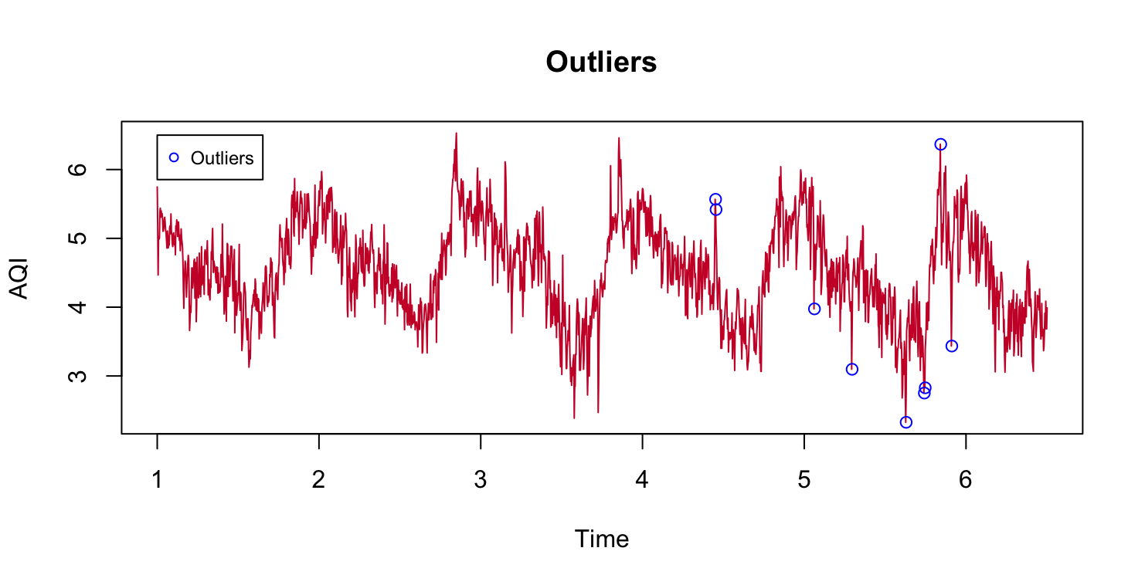 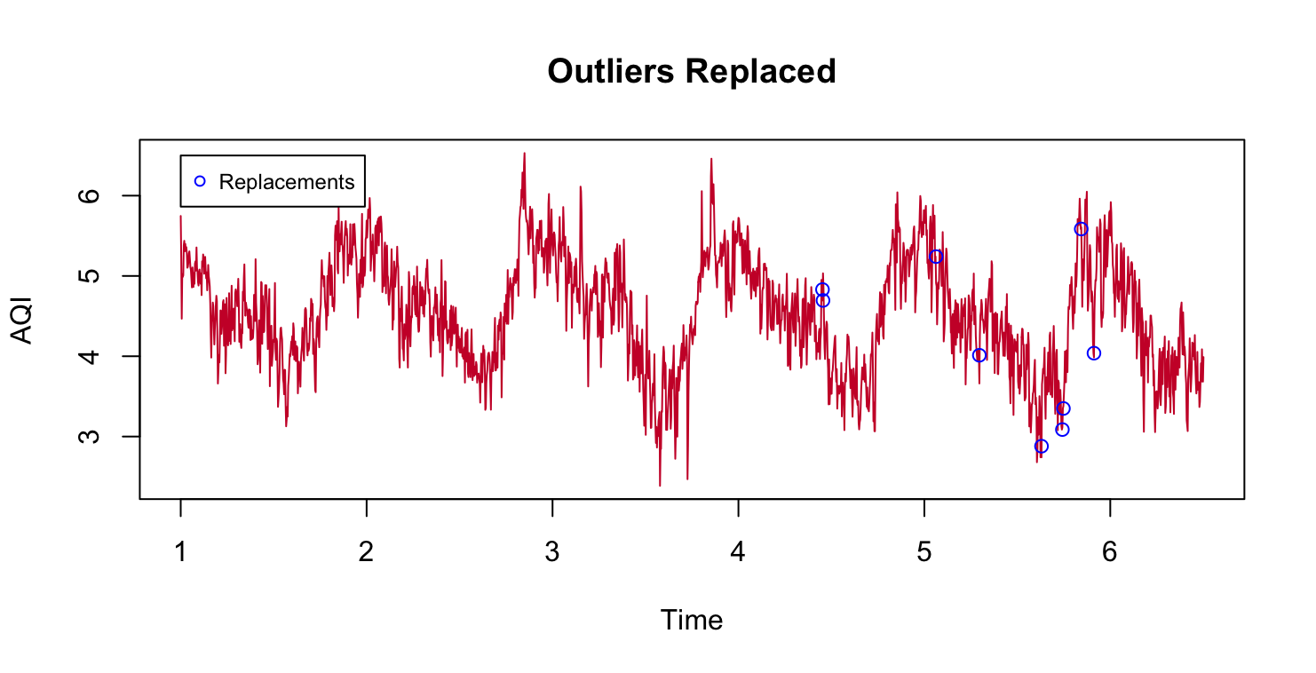

*Figure 4. Outliers Detected with their replacements.*

**2.3. Data Imputation**

For forecasting purposes, additional columns were appended or modified as required by each algorithm. Random Forests and XGBoost required additional discrete as well as continuous columns to help capture the temporal aspects of the series. These columns included date parts such as day, week, month, quarter, year along with some continuous values such as rolling average of AQI over a week (and month) for the past week and year. In order to properly encapsulate the cyclical nature of seasonality, Fourier terms, with frequencies corresponding to the factors of seasonality, were incorporated as a part of the dataset. For the GAM Model, we used similar features whereas for the LSTM based Model, only the lagged versions of time series were used.

Another point worth mentioning is that approximately a year’s worth of data was compromised in order to have the rolling average a year ago for Random Forest and XGBoost methods.

Custom out-of-sample forecast functions were written for the ML Models, since the regular test function would perform an in-sample forecasting.

**3. Modeling Methodology**

**3.1. Seasonal Decomposition**

The team started off with the most basic Seasonal Decomposition Model using Moving Average with a period of 365, since the period of seasonality is ought to be 365. The decomposition plots obtained are shown in Figure 5.



*Figure 5. Seasonal Decomposition of Log Series with Period 365*

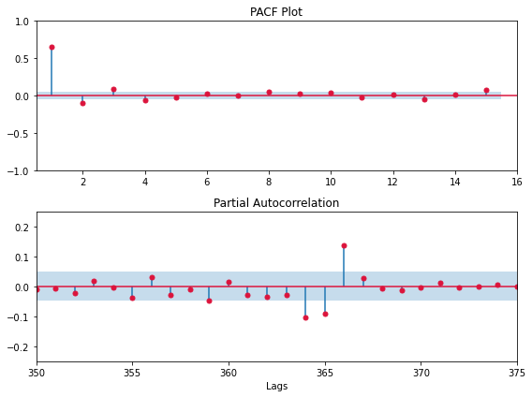

*Figure 6. ACF and PACF of Residuals from Seasonal Decomposition*

Based on Figure_6, significant lags were noticed up to the order of 4 in both the ACF and PACF Plots. Not only that, but as demonstrated in Figure_6., these lags become quite significant near the order of 365 (the assumed seasonality), thus making this model unfit.

**3.2. Auto SARIMA**

The next approach was to capture the Seasonality while factoring for the observed ARIMA nature from the previous method. Much like the previous one, the seasonality was assumed to be that of 365, and a SARIMA model was fit using the Auto ARMA function, passing the seasonality as one of the arguments. The best model chosen was SARIMA (5,1,1) (0,1,0) [365], and the following is the analysis of its residuals.

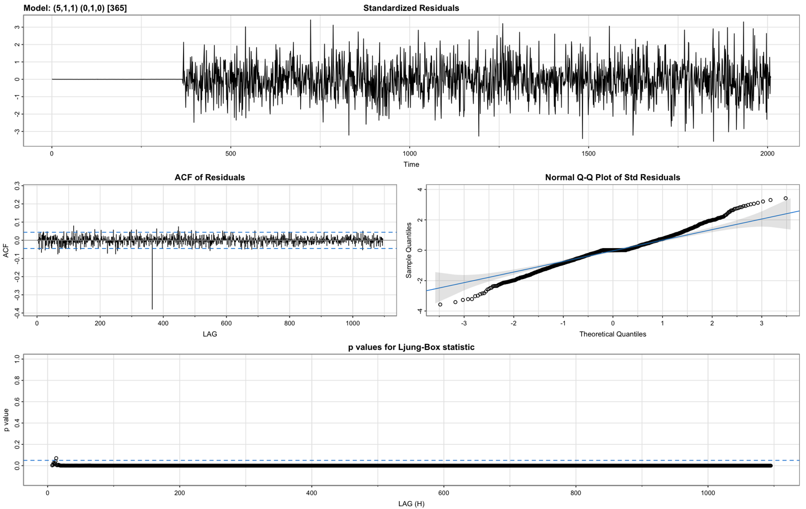

*Figure 7. Residual analysis of SARIMA Model*

From the get-go, one can notice in Figure_7 that while the residuals exhibit no pattern of seasonality, there is a very significant lag at the order of 365. Not only that, the QQ Plot also exhibits heavier tails, indicating that the residuals may not be normally distributed, violating one of the assumptions about errors. Thus, this model is deemed to be unfit as well.

This highlights a serious issue with previous modeling techniques: the assumption of a large seasonality. These models require the declaration of a fixed seasonality, and then model each term in the seasonal bracket separately. For example, in a Seasonal Decomposition Model with a period of 365, every term occurring at an interval of 365 is averaged and assigned a coefficient, which appears in the seasonal plot. Similarly, in SARIMA, the model looks back at the previous 365th term, along with a few other terms around it based on the model order and coefficients. By doing so, the model becomes overly granular and hyper-focused on terms that occurred a year apart, failing to capture the bigger picture of seasonality.

This calls for a more general technique to capture seasonality; one which doesn’t need rely solely on past values for given seasonality.

**3.3. Dynamic Harmonic Regression**

The Dynamic Harmonic Regression Technique (DHR) extracts seasonality using Fourier Transform by converting each peak or trough of seasonality into a signal with a fixed frequency. Thus, for modeling this technique, we assume a Linear Regression based ARIMA Model, where the regression terms are the sine and cosine Fourier Components, and the remaining error is modeled using an ARIMA process. The required number of components (K) for Fourier analysis is a hyperparameter to be defined by the user. DHR can model multiple and non-integer seasonality, making it advantageous.

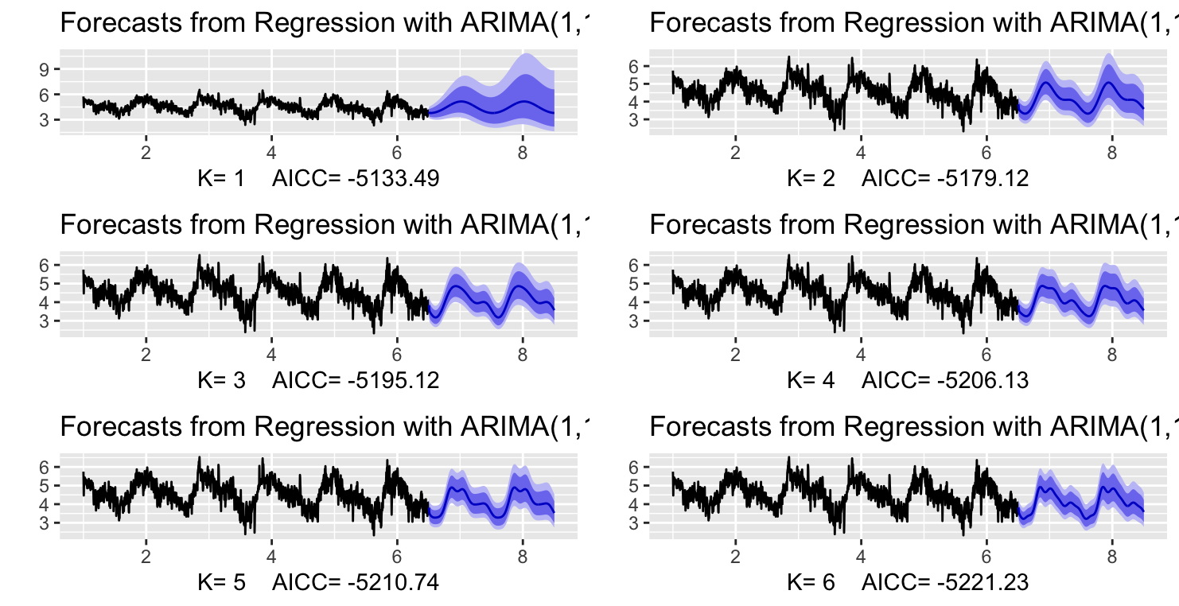

*Figure 8. Forecast for DHR Models with various values of K.*

The above shows the forecast of DHR models fitted for various values of K. As shown above, increasing the number of components, increases the resolution or specificity of the seasonality, with 1 showing the most general model, while 6 is the most specific.

Based on the above few plots, we decide on 4 as the appropriate number of Fourier Components. Thus, a DHR model with K=4 was fit, and the residuals obtained were as follows.

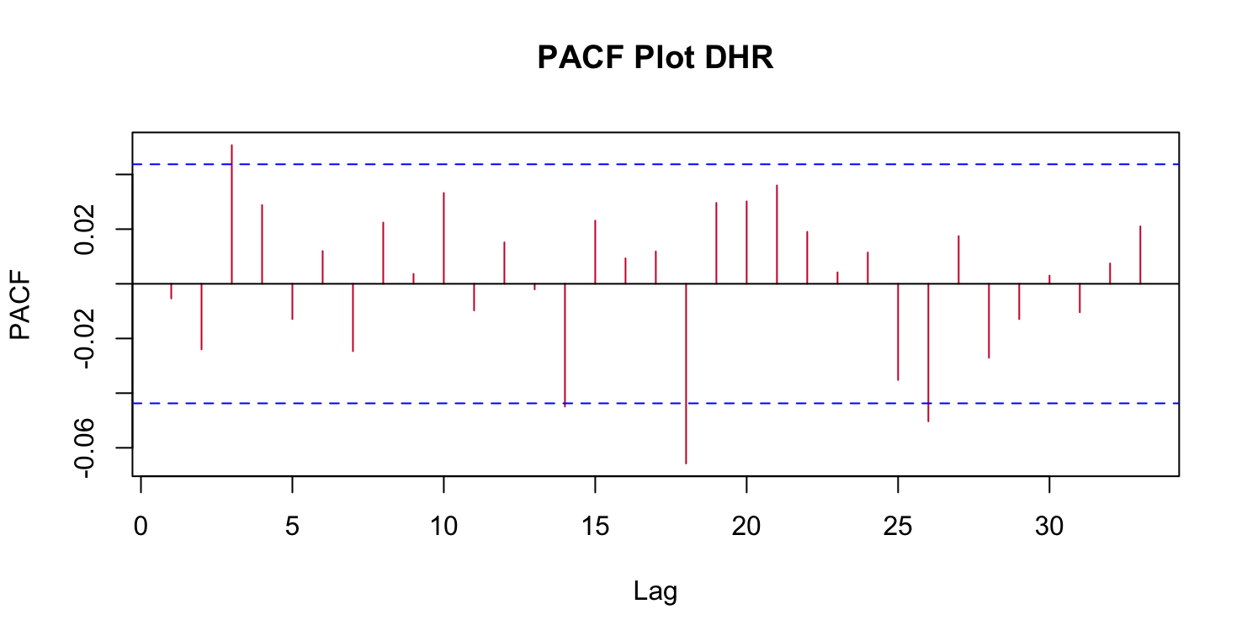

*Figure 9. Residual Plot with its ACF and PACF Plot for DHR*

As seen above, the ACF and PACF Plots show no significant lags, indicating stationarity, so far.

**3.4. TBATS**

TBATS (Trigonometric Seasonal Exponential Smoothing State Space Model) is one such time series forecasting technique that can handle multiple seasonalities and changing trends. It also applies Box Cox Transformation to handle non-linear trend, and then uses ARIMA to model the error. Unlike the previously mentioned DHR, which uses Fourier Transform to extract seasonality, TBATS uses a combination of trigonometric functions and exponential smoothing to capture multiple seasonalities with varying frequencies. Furthermore, TBATS incorporates a trend damping parameter that allows the model to adapt to changing trends, which DHR was incapable of.

Fitting our data in the TBATS function with a pre-specified order of 365.25, results in a TBATS Model of the order (1, {2,3}, -, {<365.25,4>}). Here, the first ‘1” stands for Box-Cox Transformed, the {2,3} is the ARMA Error, and {365.25,4} means that 4 pairs of sine and cosine terms were needed to model the seasonality. The forecast wherein the seasonal pattern looks similar to DHR is shown below in Figure 10.



*Figure 10. Forecast with the TBATS Model*

The residual plot along with their corresponding ACF and PACF Plots are shown below in Figure_11. From those plots, it is evident that the resulting series is indeed stationary, but further analysis is done before confirming it.



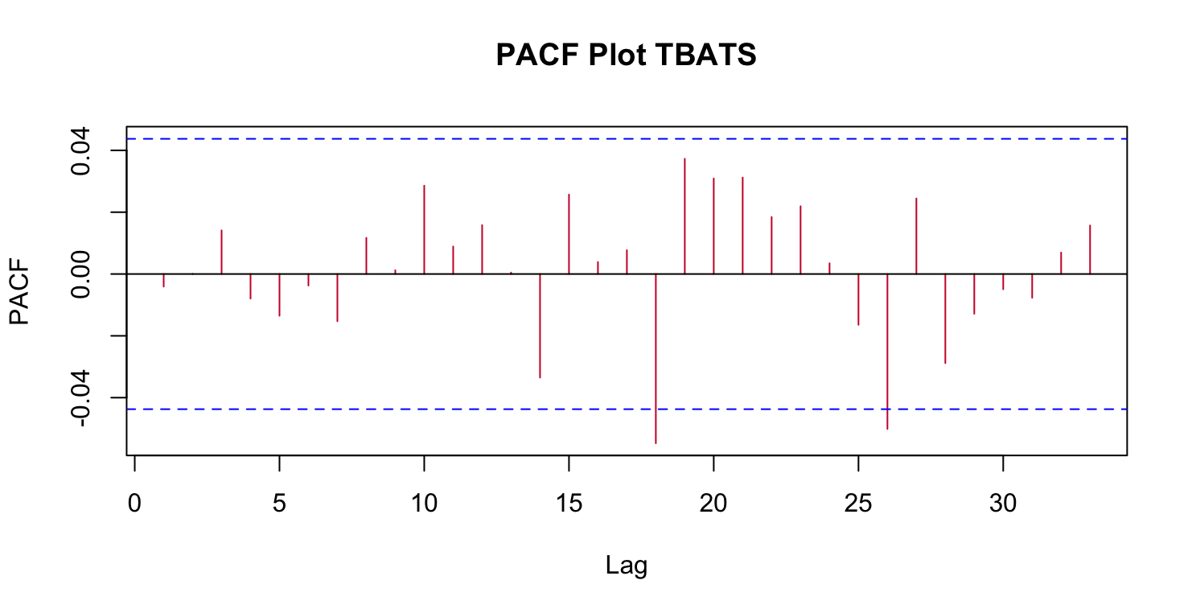

*Figure 11. Residuals of TBATS Model with their ACF and PACF Plots*

**3.5. Random Forest**

Random Forest is an ensemble method which implements Bagging (Bootstrap Aggregations) on top of several Decision Trees, followed by random sampling of variables for variability. For Time Series Forecasting specifically, the way this is done by regressing over lagged functions of time up to the order of 7, to emulate the auto-regressive nature of Statistical Models. As a common practice, the seasonal and trend terms are adjusted before using the same. However, in this case, the aim was to identify an RF Model’s strength to pick up the seasonality by itself, and hence used some external variables (as mentioned in the earlier section) to forecast. These variables helped the model in determining the temporal features like the day, month, year etc. To keep track of values beyond lag, some continuous variables like weekly average of AQI in the past week were used. Since it would be infeasible to have lags up to 365 for the annual seasonality, the same was substituted by weekly average of the same day, a year ago. The hyperparameters were decided after running a simple Bayesian Optimization method, aimed at minimizing the cost function, RMSE in this case. The residuals plot and ACF, PACF Plots are shown in the figure below.

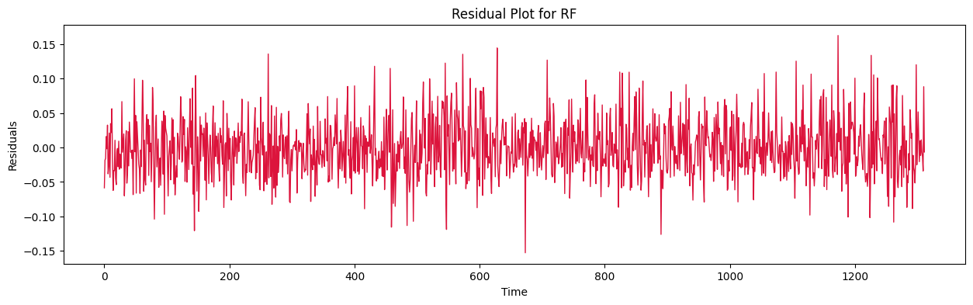

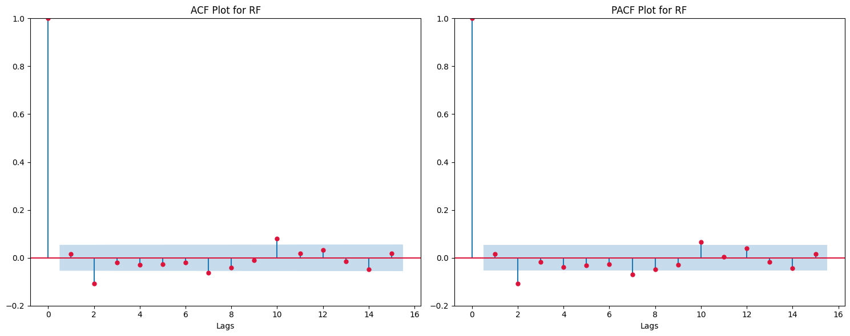

*Figure 12. Residuals of Random Forest Model with their ACF and PACF Plots*

**3.6. XGBoost**

XGBoost (Extreme Gradient Boosting) is another Ensemble Method based on Booting, where several weak learners fit the model sequentially. These weak learners are typically referred to as “stumps” which are shallow trees. The application and principle remain the same as it was for Random Forest. Both these models shared the same set of variables. The plot below in Figure_13 shows the residuals, ACF and PACF for the same.

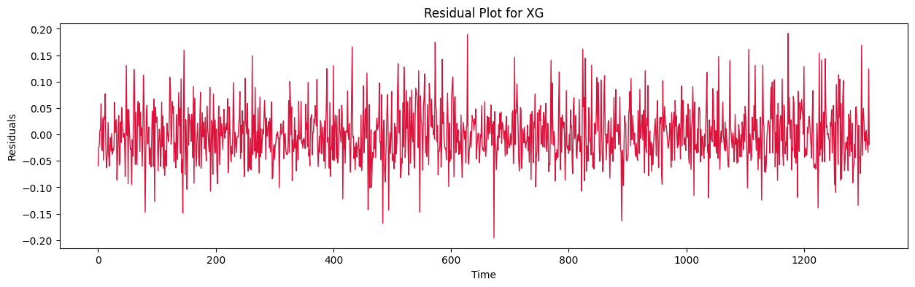

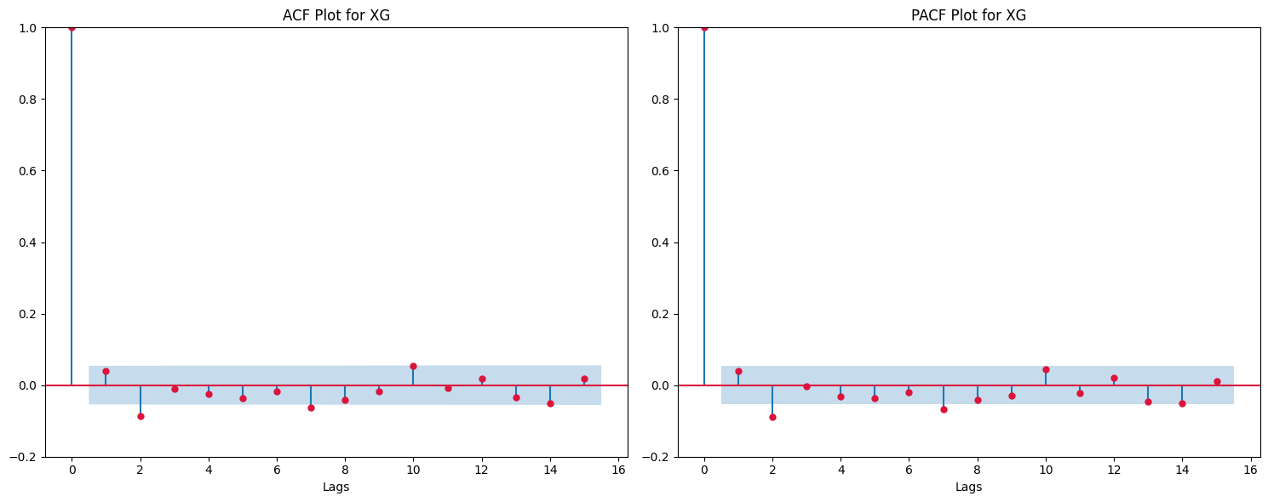

*Figure 13. Residuals of XGBoost Model with their ACF and PACF Plots*

**3.7. GAM**

General Additive Model or GAM is another regression method where regressors (or additive components) are expressed using smoothing splines and their coefficients are calculated against the target variable, often via a link function. The GAM function in R usually has a term for correlation matrix wherein one can use the corARMA function to introduce ARIMA terms, but here, a separate ARIMA function was fitted on the residuals.

In our case, a dataset was crafted specifically for this method where we ended up using two variables; a year variable to capture the trend across the years and the other was a “day_num”; just an enumeration of the specific day number of the year. For year, a cubic regression spline was fit, whereas for the other column, a cyclical P-spline was used as smoothing functions. The plot below shows the residuals and ACF, PACF for the same in Figure_14.

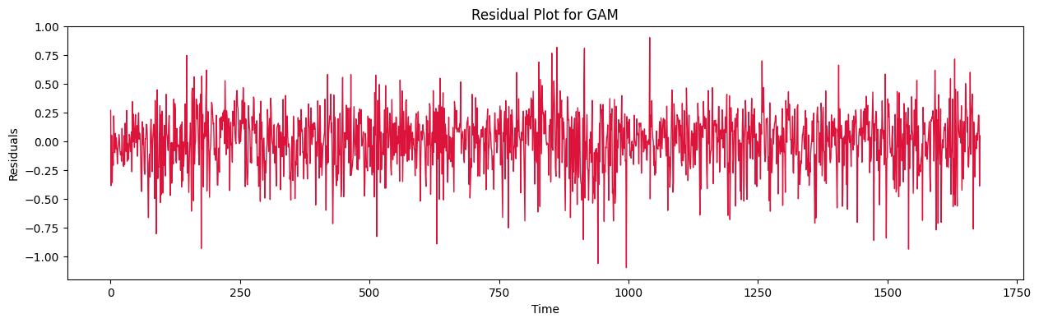

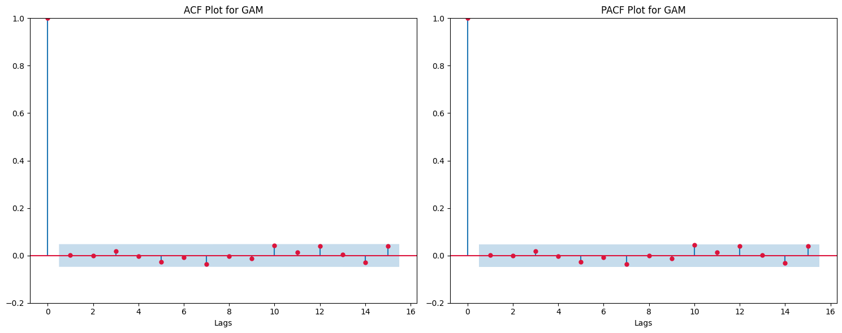

*Figure 14. Residuals of GAM Model with their ACF and PACF Plots*

**3.8. LSTM**

Long Short-Term Memory (LSTM) networks are a type of recurrent neural network (RNN) designed to overcome the limitations of traditional RNNs in capturing and remembering long-range dependencies in sequential data. LSTMs introduce a memory cell and a set of gates that control the information flow into and out of the cell, allowing them to learn and store information over longer sequences. Long Short-Term Memory Cells typically find applications in Natural Language Processing using Neural Networks, but their memory capturing property makes them useful in capturing patterns in Time Series related Data. The data points are however not sufficient and resulted in a poor model. To compromise for the lack of sufficient data points, we de-season the data using DHR, and leave in the trend for the model to figure out.

The hyperparameters for the same were optimized using the Hyperband Optimization. The respective Residuals, ACF, PACF are shown in Figure_15.

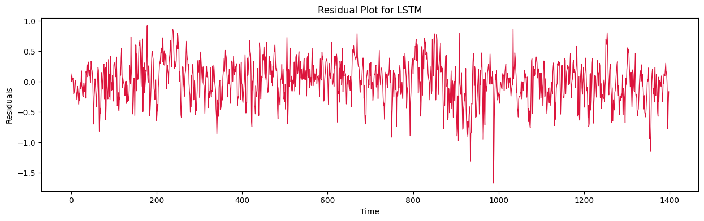

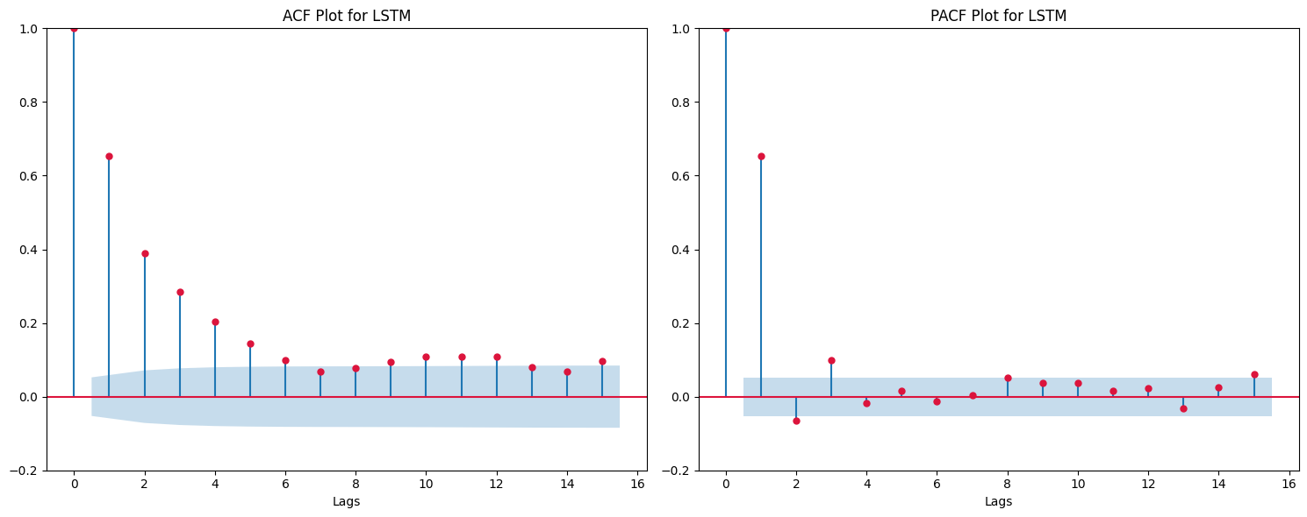

*Figure 15. Residuals of LSTM Model with their ACF and PACF Plots*

Based on the above plot, it is safe to conclude that surprisingly, LSTM Model was unable to capture the Auto-Regressive nature of the series. This can be owed to the lack of dataset.

**4. Observations**



*Figure 16. Trend and Seasonal Pattern of TBATS Model*

The overall Trend and Seasonality of the model are shown below in Figure 16. Firstly, an overall decline in PM2.5 trend is observed. This dip is especially evident in the last few months, corresponding to the months of lockdown following the COVID-19 pandemic. One interpretation of this could be the inverse relationship of human activities and PM2.5 concentrations. As for the seasonal pattern, the winter months are shown in blue, the summer ones in red and the monsoon ones in orange yellow. From this, two things are implied – 1) Inverse relationship of Temperature and PM2.5 concentration. 2) Inverse Relationship of Rainfall and PM2.5 concentrations

The forecasts for all the models are shown below:

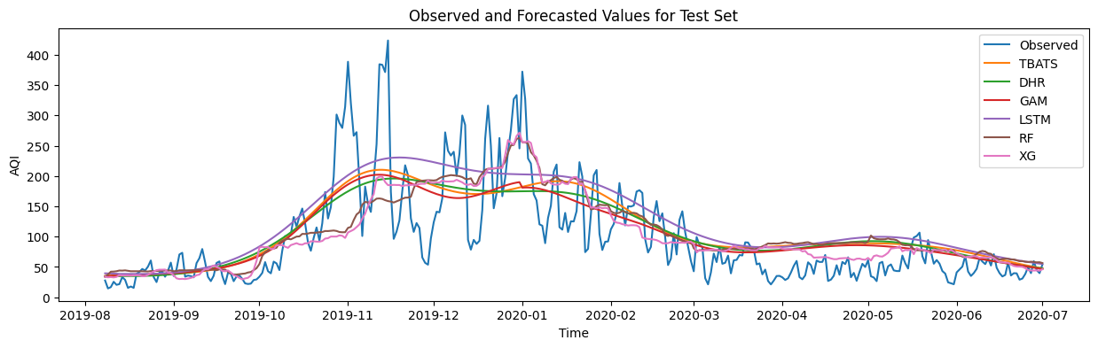

*Figure 17. Observed Values and forecasts of all the models.*

As seen above in Figure 17, all the models perform well in generalizing the overall forecast. While the Statistical Methods display a smooth forecast, the regression-based forecasts were discontinuous or discrete functions since the prediction was made for each day, as opposed to fitting a general curve. For generalizing purposes, smoother outputs are more reliable, while on the other hand, having a discrete output may be better for instances where a model would profit by the specificity of the data. In short, it’s a classic case of striking the perfect balance between generalization and specificity.

|  |  |  |
| --- | --- | --- |
| Method | Train RMSE | Test RMSE |
| Random Forest | 27.54 | 59.41 |
| XGBoost | 29.80 | 57.23 |
| TBATS | 37.67 | 54.75 |
| DHR | 38.29 | 54.91 |
| GAM | 37.18 | 51.75 |
| LSTM | 50.96 | 57.92 |

*Table 1. Train and Test RMSE for all the forecasts(retransformed)*

Based on Figure 17 it is obvious how Random Forest and XGBoost Models have overfit, despite having tuned the models. From the Statistical Methods, GAM performs the best. When observed closely, a shift in peaks in observed for TBATS and DHR Models. The two peaks (around the beginning of November and early January) is noted, which, however, appears to be shifted in the two models. Whereas the peaks coincide well with the GAM Model’s Forecast. There is non-constant variance observed in the original plot, which can be easily resolved using ARCH Models, as was done with DHR and TBATS Model.

Table 2 displays the result of various tests conducted on the residuals and their squared values.



*Table 2. Ljung Box and ARCH Test for TBATS and DHR Models*

As seen, there is some ARCH effects in both the models which is handled easily by fitting an ARCH (1) Model. The Table 3 below shares the results again.



*Table 3. Ljung Box and ARCH Test for TBATS and DHR Models after fitting ARCH(1)*

Later, these functions were deployed on a local server, TabPy, serving as a connector between Tableau and the Jupyter Notebook. This allowed a dynamic connection between the two allowing real-time interaction and execution of functions. The snapshot below shows a Dashboard created on Tableau.

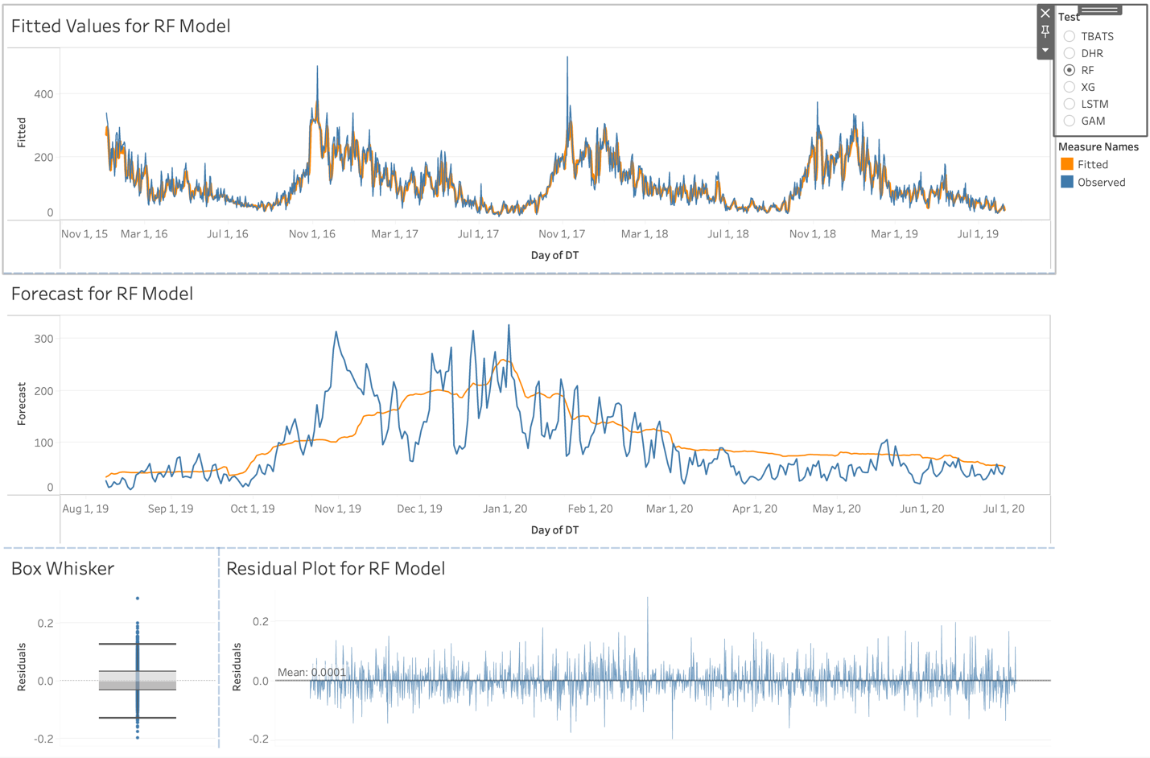

*Figure 18. Tableau Dashboard displaying the forecasts.*

**5. Conclusion & Future Scope**

In the analysis of pollutant concentrations, statistical models are favored for capturing long-term seasonality trends, especially as PM2.5 levels exhibit a declining trend. The impact of weather and seasons emerges as a significant factor influencing pollutant concentrations. While Long Short-Term Memory networks (LSTMs) are effective, they demand a sizable dataset for optimal training. Alternatively, Random Forests and XGBoost prove to be valuable for forecasting, with a caution against overfitting.

Exploring the spatial-temporal pattern of the city could be crucial, necessitating consideration of variables like temperature, wind, and traffic for a comprehensive analysis. Another aspect, barring the missing values, could be hourly-distribution of pollutants, and forecasting the same.

**6. Reference**

**6.1. Appendix:**

The code and related files for the project can be found here: <https://github.com/Rahul-Rut/Time_Series_Analysis_PM2.5_Delhi/>

**6.2. Citations:**

Kneib, T. Comments on: Inference and computation with Generalized Additive Models and their extensions. *TEST* **29**, 351–353 (2020). <https://doi.org/10.1007/s11749-020-00713-3>

**6.3. Bibliography:**

1. Dataset Link: <https://www.kaggle.com/datasets/rohanrao/air-quality-data-in-india?datasetId=630055&sortBy=voteCount&select=city_hour.csv>
2. Indian AQI Formula Specifics: [https://www.pranaair.com/us/blog/what-is-air-quality-index-aqi-and-its- calculation/](https://www.pranaair.com/us/blog/what-is-air-quality-index-aqi-and-its-%20calculation/)
3. TBATS Model Research Paper: <https://robjhyndman.com/papers/ComplexSeasonality.pdf>
4. Textbook for DHR: <https://otexts.com/fpp2/dhr.html>
5. Outlier Treatment: <https://robjhyndman.com/hyndsight/tsoutliers/>
6. Random Forests for Time Series Forecasting: <https://www.sarem-seitz.com/posts/forecasting-with-decision-trees-and-random-forests.html/>
7. GAM for Time Series Forecasting: <https://petolau.github.io/Analyzing-double-seasonal-time-series-with-GAM-in-R/>
8. Regression Splines: <https://cran.r-project.org/web/packages/crs/vignettes/spline_primer.pdf>